

Operating System

Lab#04

I/O Redirection

Task 01: Perform the following tasks:

- Write a single command to copy the contents of /etc/passwd into out.txt without using cp command. (Hint: I/O Redirection)
cat /etc/passwd > out.txt

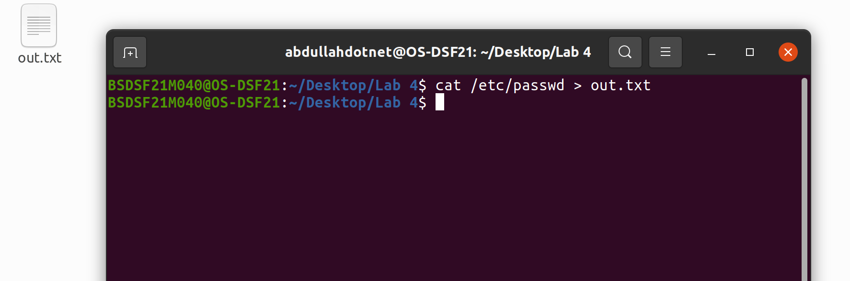

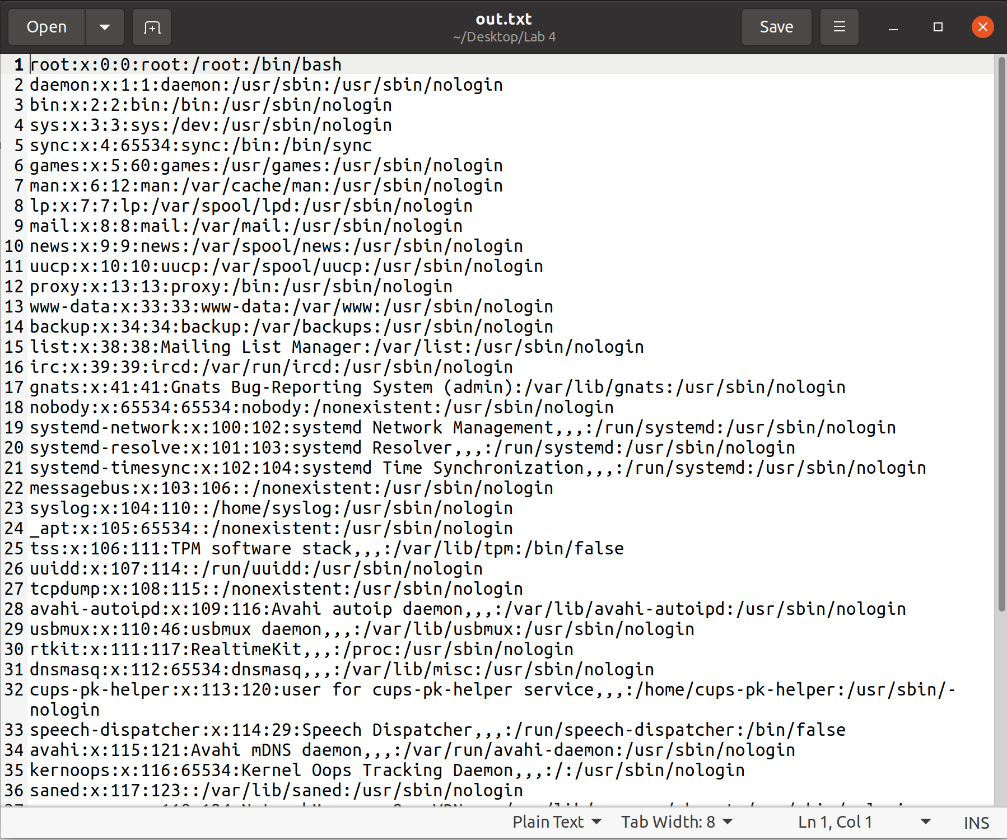
- Find all the files named *libc.so* in your root directory (using find command) and redirect the output to libc_locations.txt, and errors to /dev/null.

find / -name libc.so > libc_locations.txt 2> /dev/null
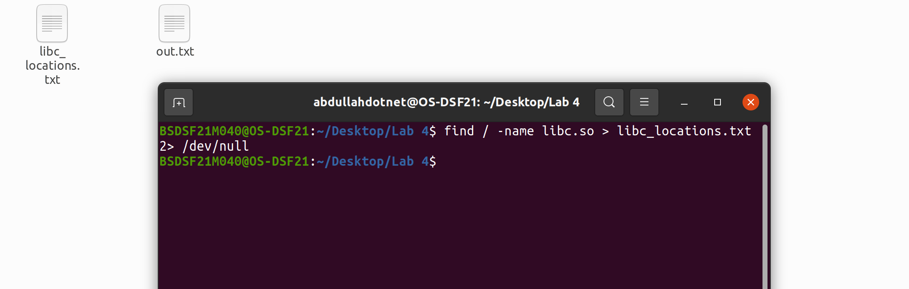
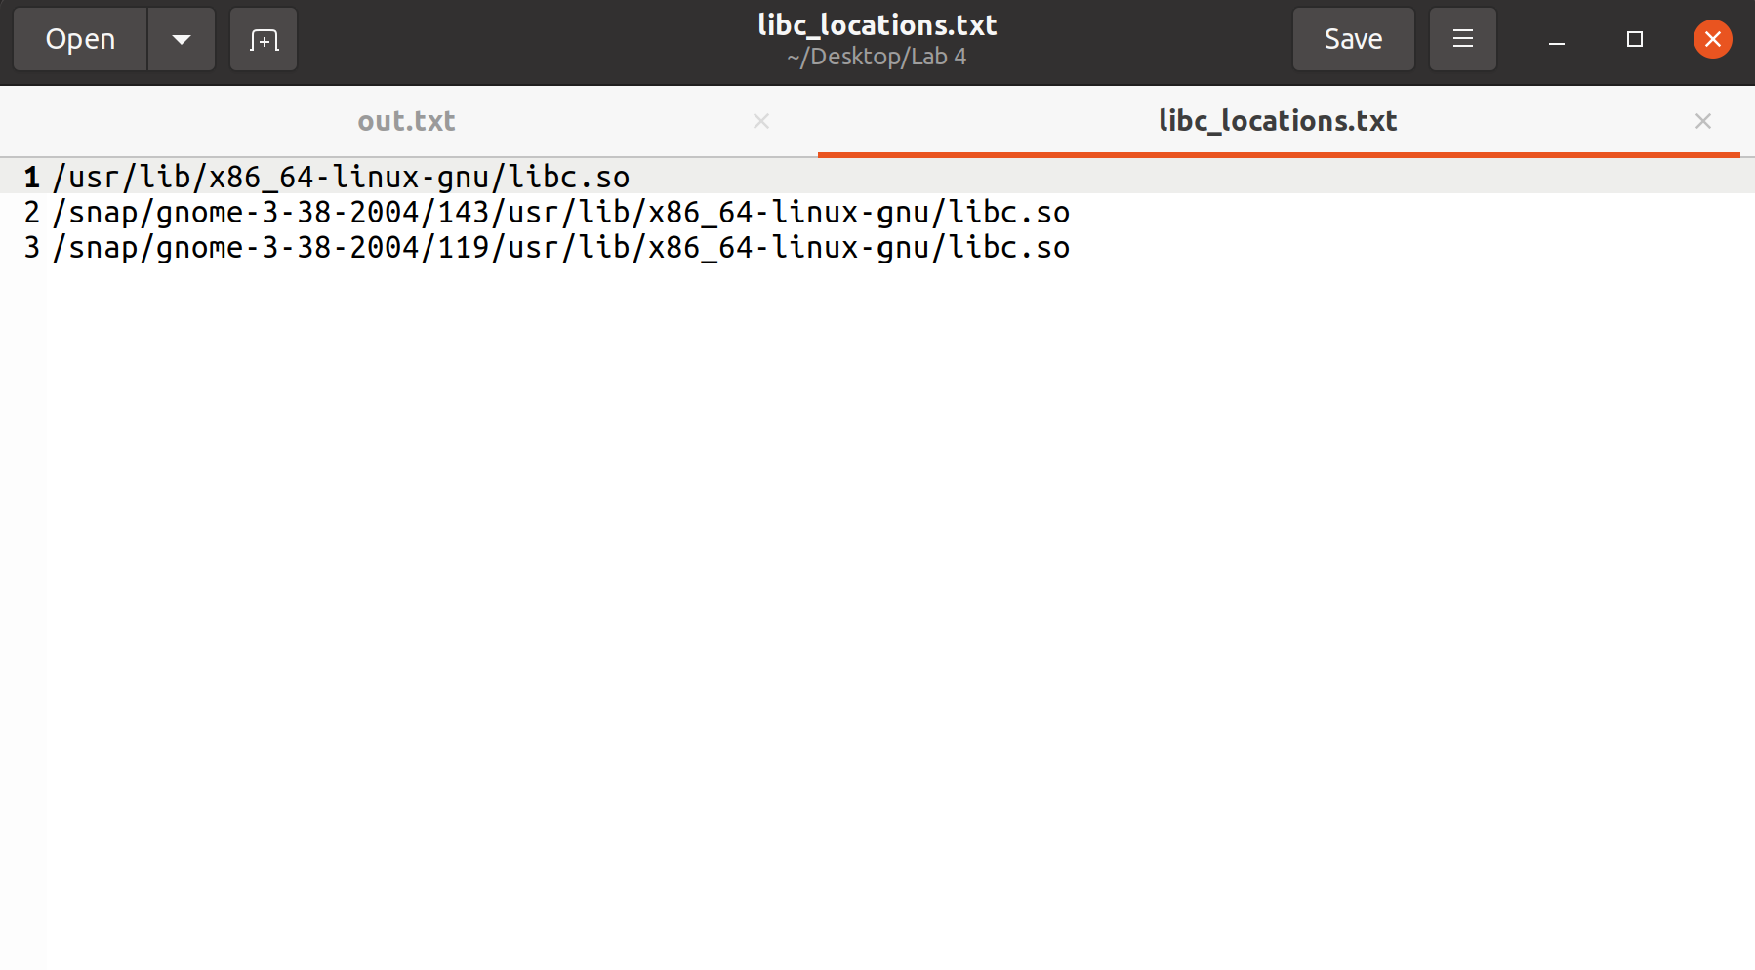
Task 02: Perform the following tasks:

- Write a single command to add “Hi, I am <Your Name>” into myself.txt. (Hint: Use echo command)
echo “Hi, I am Muhammad Abdullah Ghazi” >> myself.txt
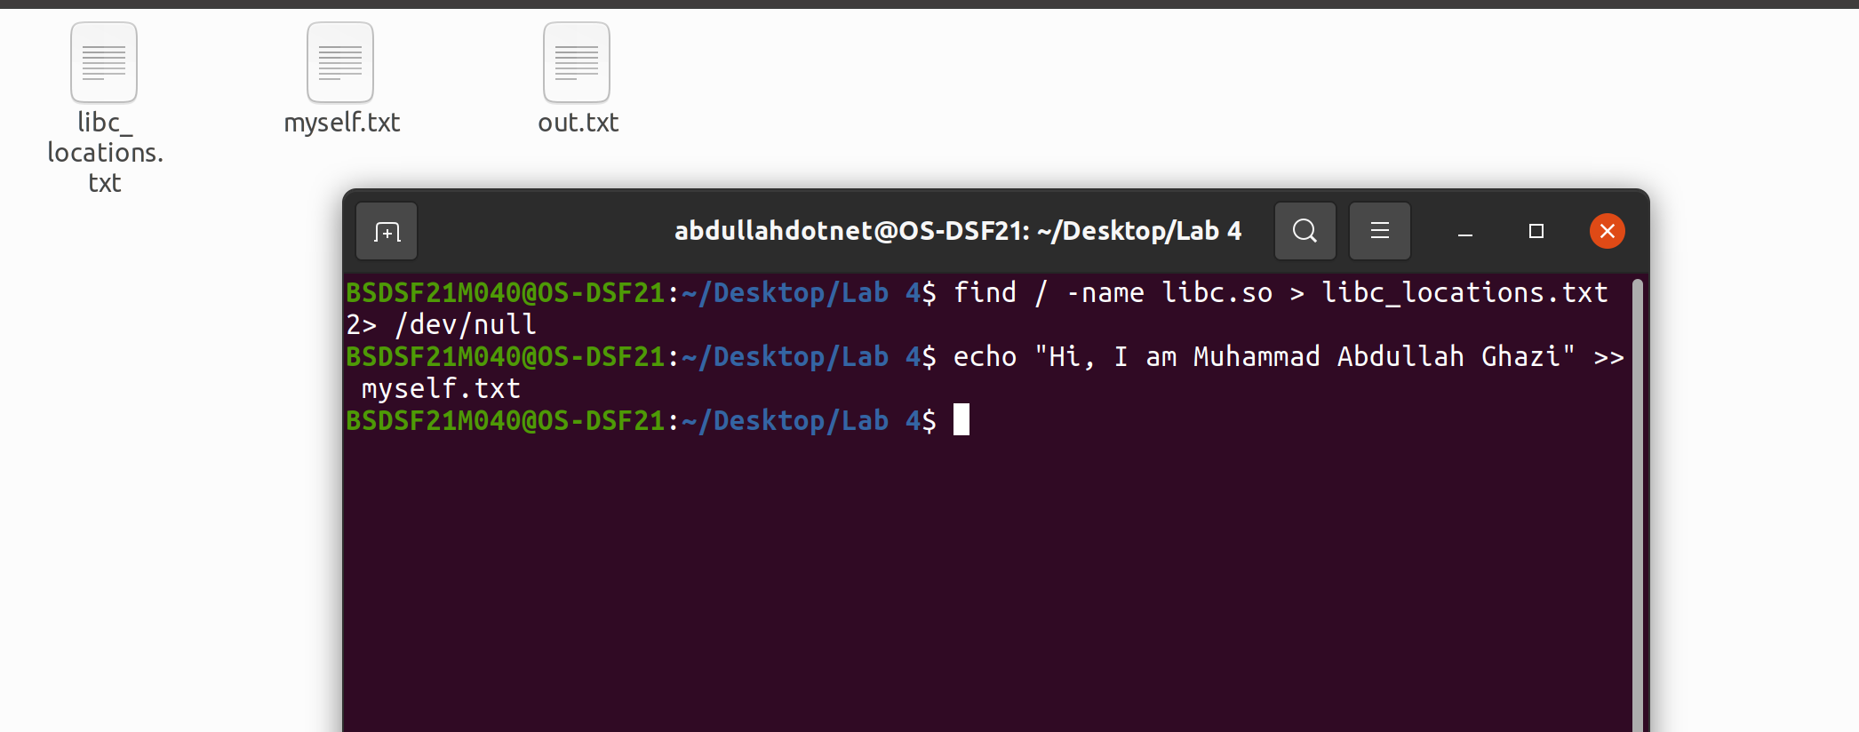
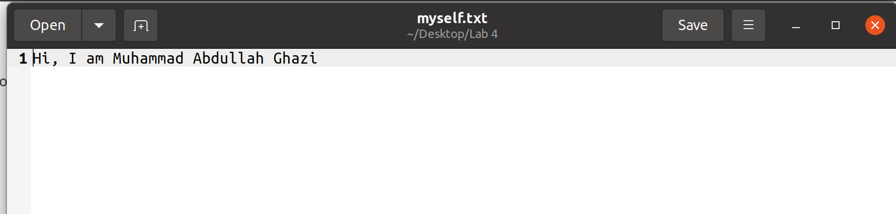
- Append “My Roll No is : <Your Roll No.>” using IO redirection.

echo "My Roll No is : BSDSF21M040" >> myself.txt

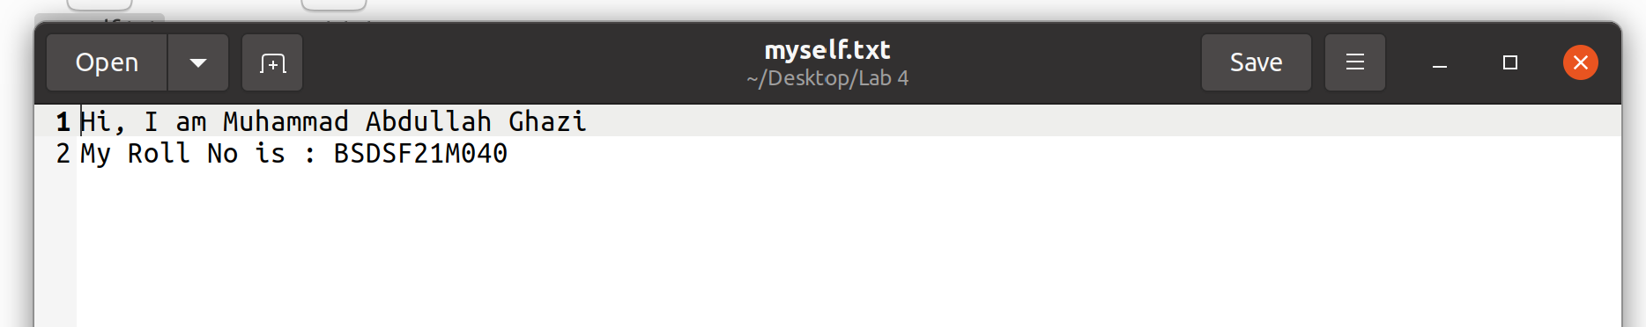

Task 03:


#include<stdio.h>

#include<unistd.h>

#include<fcntl.h>

int main(void) {
int fd = open("/tmp/fake", O_RDONLY);

perror("ARM: Can't open file");

printf("Ever wanted to be a Hacker?\n");
printf("If Yes, Work hard and learn how OS throws errors to other files.\n");
return 0;

}

Save the above given source code as hacking.c. Compile and make executable of the hacking.c and
perform I/O redirection operations as described below:

- Redirect the output to a file named work_hard.txt.
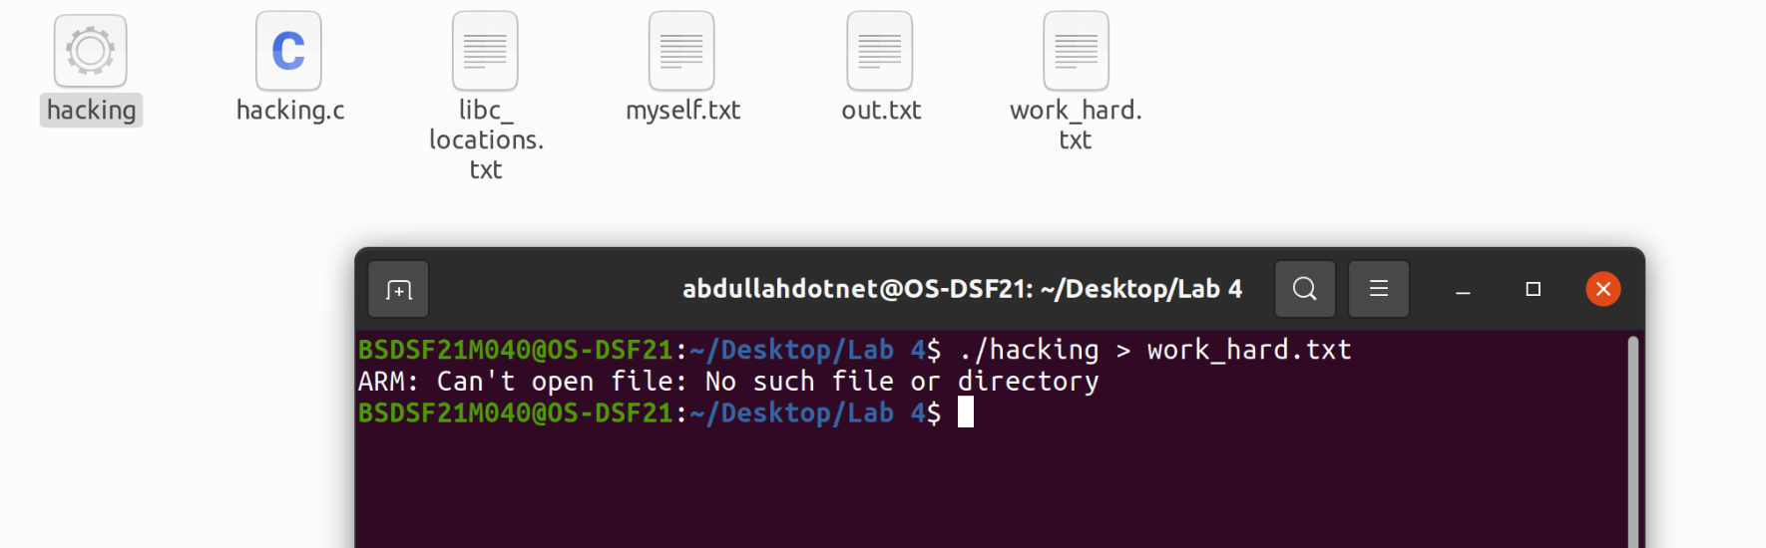

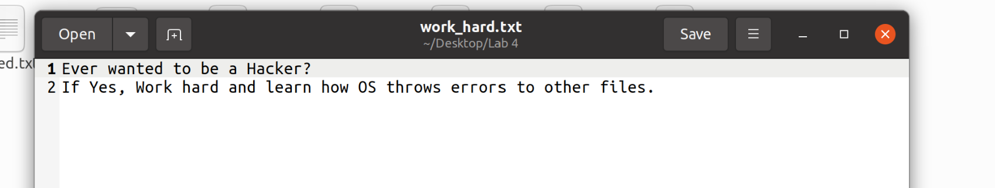

- Redirect the error to a file named failed.txt.
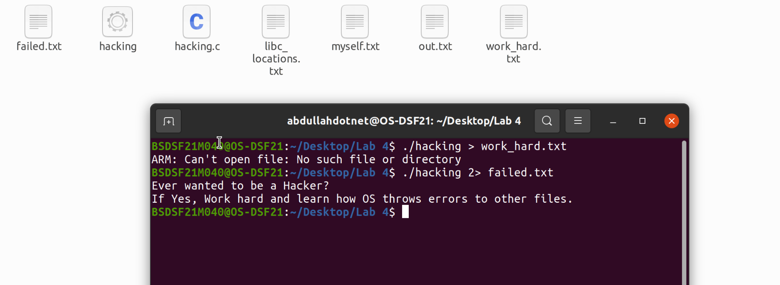

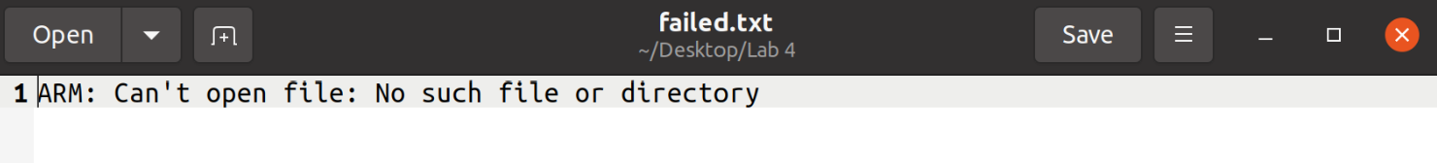

- Redirect the stdout and stderr to a file called screen_copy.txt using copy descriptor.
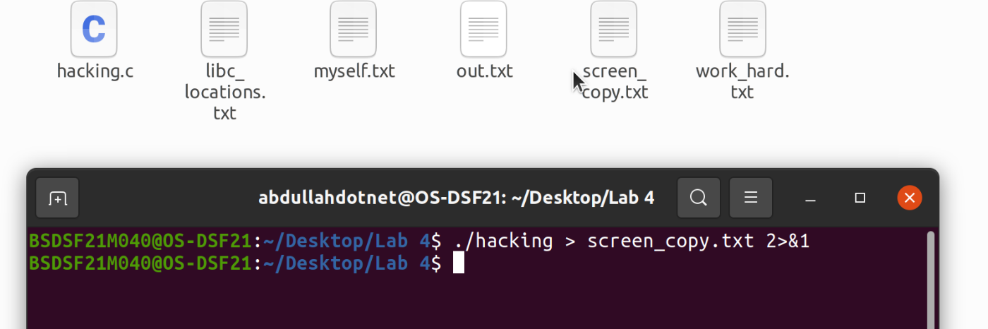

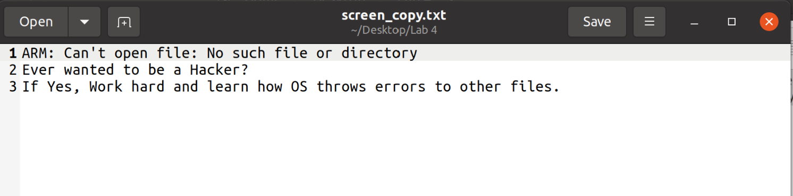

Pipes/Fifos

- Write a single command to display all the lines containing kali in /etc/passwd counts the number of lines in the output.
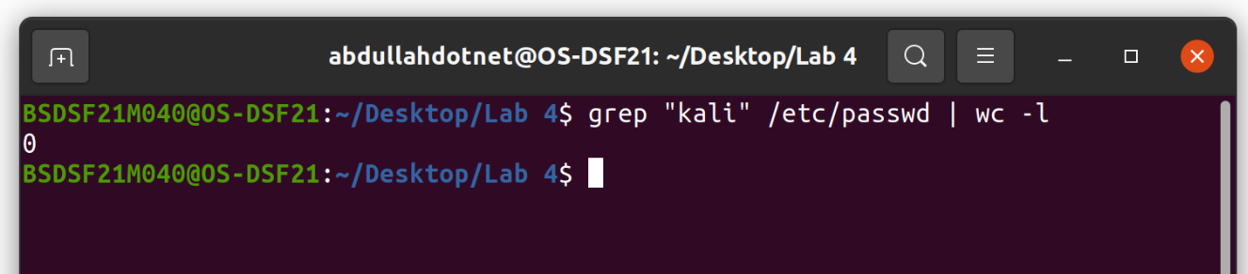
- Write a single command to count the occurrences of word root in /etc/passwd.

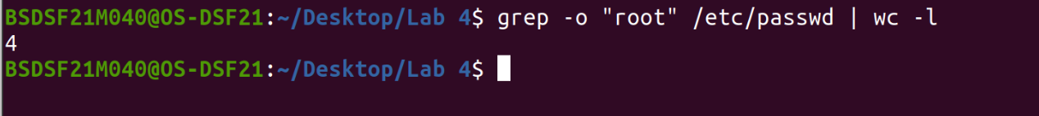

- Draw PPFDT of each process that was created in the above questions.
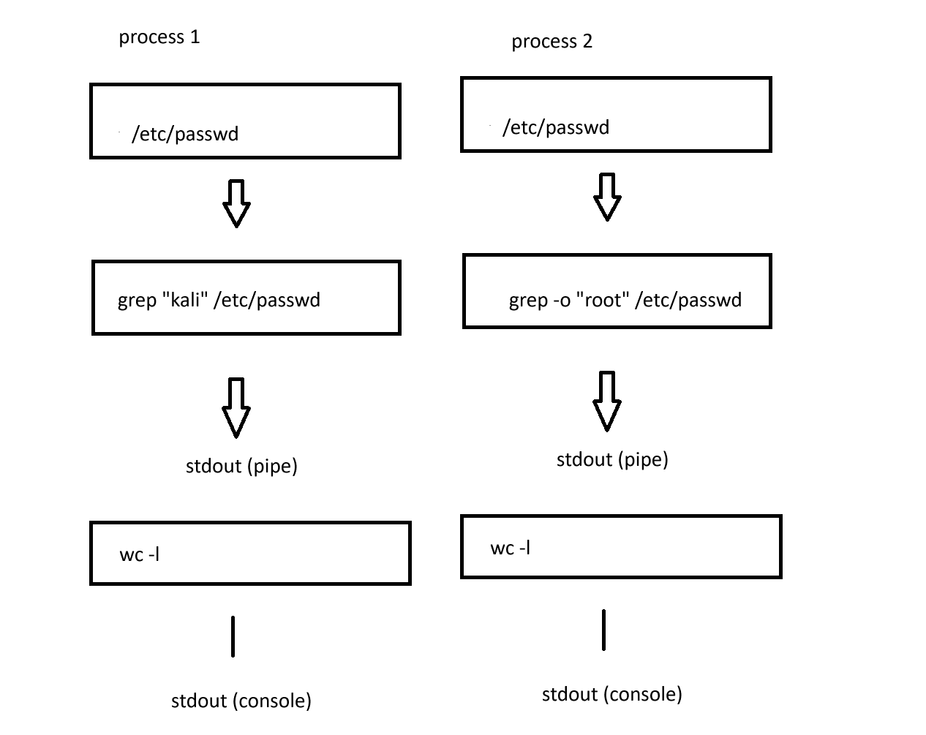

Task 03: Write a single command which will copy the source code hacking.c (I/O Redirection: Task

- on stdout and in the following files: advice1.c, advice2.c, advice3.c. (Hint: use tee command)

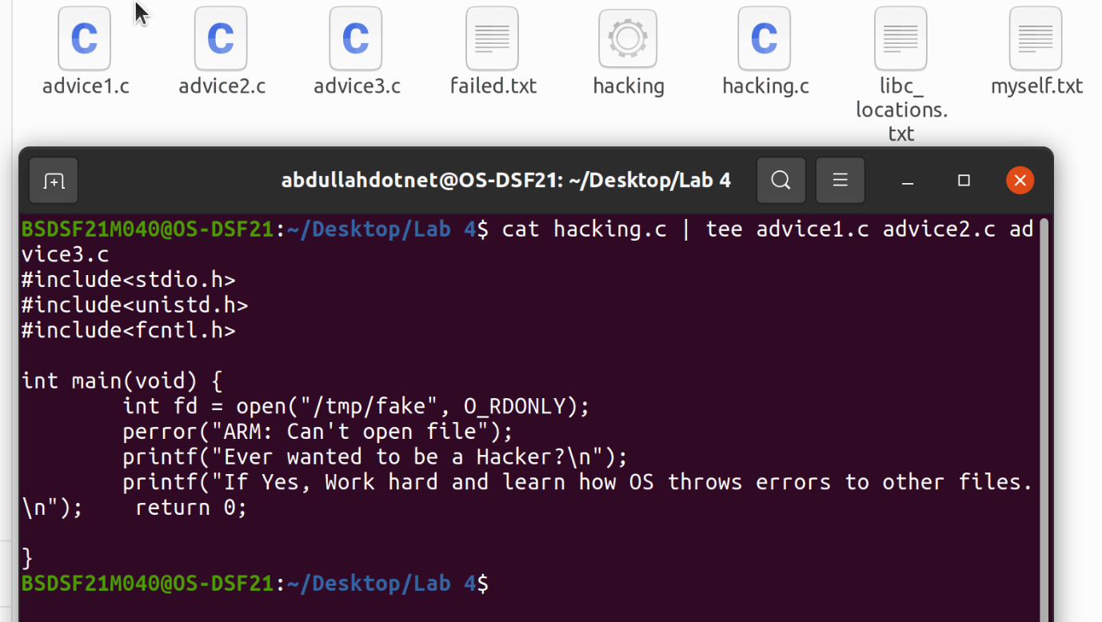

Task 04: Create a fifo called transporter. Open two shells and display the contents of the advice1.c (created in the above task) on both shells.
(Hint: Use tee command to save data in transporter and on second shell use any command to read transporter)

